Office of the Registrar Add and Override Approval

E-Mail: registration@wayne.edu

If you receive an error when trying to register for a class, you may need prior approval.
- Complete the Courses to Add table below with the course information.
- Obtain the instructor’s signature.
- Contact the academic department offering the course (e.g. Psychology) for the appropriate override. A confirmation email will be sent to your WSU email account when the override is entered. Course AUDITs and PASS/NO PASS transactions must be manually registered by Registration Services.
  - 1st Week of Classes - students must register themselves via Academica
  - 2nd Week of Classes - students must register themselves on Academica AFTER the Academic Department enters the appropriate override code (LA).
  - 3rd Week of classes and beyond - LATE registration transactions must be manually registered by Registration Services. Forward the confirmation email with your WSU ID and the CRN(s) to registration@wayne.edu for processing.

ID | Last Name | First Name | Term/Year
Signature X |  |  | Date
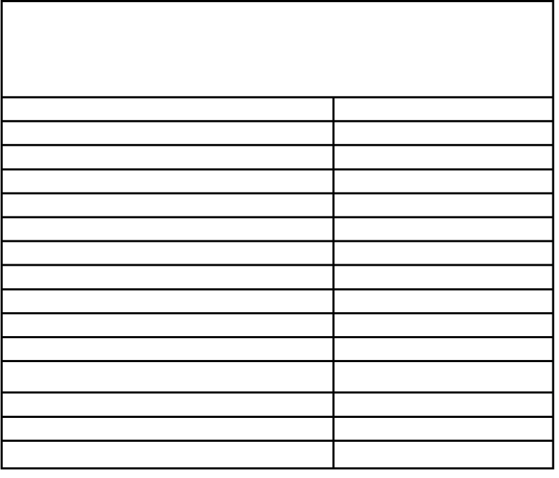
Academic Department Use
- Enter the appropriate override code on SFASRPO
- Instruct the student to register via Academica
Situation Class (Rank Restriction) Closed or full class
Co-requisite requirement College Restriction Degree Program
Written consent needed Duplicate Courses Allowed Second Week Add Permit Undergrad in Grad Class Major Restriction
Pre-requisite met Program Restriction Repeat class limit/hours
Time conflict
Override Code CLASS CLOSE COREQ COLL DEGREE
DEPT DUPL LA LEVEL MAJOR
PREREQ PROGRAM REPEAT
TIME
Academic Department Use
- Enter the appropriate override code on SFASRPO
- With these overrides, this form needs to be manually processed by the Records and Registration Office
Situation Override Code
Student Auditing a Class AUDIT Register/Add Late (3rd week and beyond) LATE
Pass/No Pass grading option PASS

Courses to Add
CRN | Subject | Course # | Section # | Credit Hours | Instructor’s Signature
54610 | PSY | 3350 | 001 | 3 | Professor Sample
Check the Schedule of Classes website (www.classschedule.wayne.edu) for deadline and tuition cancellation dates.

Office of the Registrar November 2016

