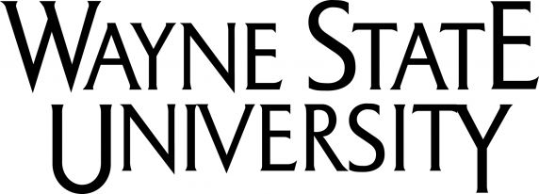
A T T E N T I O N :
All Department of Communication Students!
Journalism Day Internship Fair is coming!!

Wayne State University announces its annual event sponsored by the Journalism Program,
Department of Communication, College of Fine, Performing and Communication Arts.

This year it is scheduled for:

Thursday, October 19, 2017
In the Italian Room, General Lectures
9:00 – 11:30 a.m.

Historically, we have gathered a wide-range of representatives from television, radio, print, new media, public relations and other communication outlets who have met with more than 200 WSU students to interview, collect resumes, hand out literature and give tips on applying for an internship -- the first step to getting a job in your field. Personnel from Career Services will also be on-hand to help students with their resumes and cover letters – please bring your resumes and cover letters with you!
Students in Journalism, Public Relations, Media Arts, Film, Dispute Resolution, Forensics and Communication Studies should plan on attending:

1. Please come “dressed for success!”
2. Bring your resume with you.
3. Anticipate networking with valuable internship possibilities. You could be meeting your next job!
See you at The Fair!!
Sincerely,
Jack Lessenberry
Area Head/Journalism
Internship Coordinator

For more information, contact Carol Horn in the Journalism Office,
Department of Communication, 553 Manoogian Hall, (313) 577-2627; C.N.Horn@wayne.edu

